Hidden Patterns, Outliers & Spurious Correlation
Case Study Assignment — Solved Questions

Name: EDRIN J S
Roll No: 192524041
Course: Query Processing
Date: 23-08-2026

Question 3: Study Time and Academic Performance (Hidden Subgroups)
A professor studied the relationship between weekly study time and academic performance for 2,000 students and found an overall correlation of only about 0.35, concluding that 'study time has almost no relationship with academic performance.' However, when students were divided by their level of preparation, a very different picture emerged. This is examined below.

1. The Reported Pattern
The overall (pooled) correlation and the correlation within each preparation subgroup are summarized below and visualized in Figures 3.1 and 3.2.
Group | Correlation (r) | Interpretation
Overall (Pooled, all students) | 0.35 | Weak positive — appears to support the professor's conclusion
Well-Prepared Students | 0.91 | Very strong positive — study time matters a great deal
Moderately Prepared Students | 0.63 | Moderate positive relationship
Poorly Prepared Students | 0.06 | Essentially no relationship
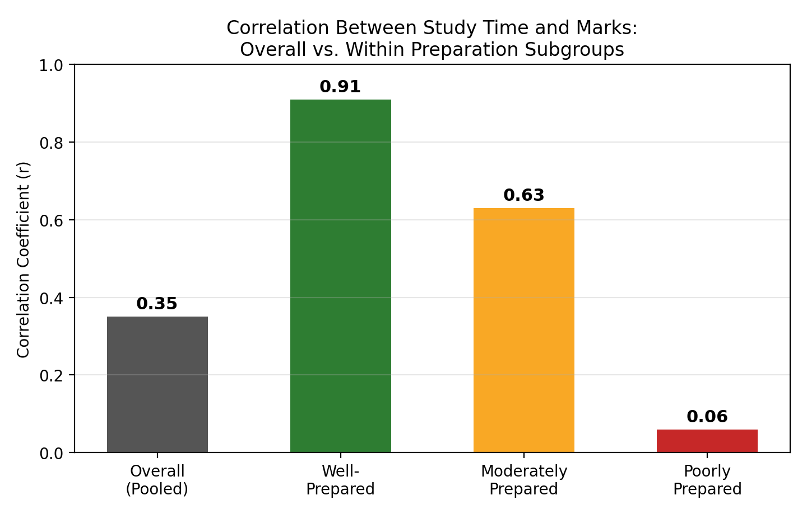
Figure 3.1 — The pooled correlation (0.35) masks very different relationships within each preparation subgroup, ranging from 0.91 to nearly 0.

2. How a Single Overall Correlation Can Hide Important Patterns
The weak overall correlation is an aggregation artifact, not evidence that study time is unimportant. It arises because the sample is a mixture of three structurally different subpopulations, each with its own study-time-marks relationship (see Figure 3.2). Averaging across these subgroups blends a very strong effect (well-prepared students), a moderate effect (moderately prepared students), and almost no effect (poorly prepared students) into a single misleadingly weak number. This is conceptually the same aggregation problem seen in Simpson's Paradox: a meaningful grouping variable — here, level of preparation (which likely reflects prior foundation, conceptual clarity, or effective study technique) — is hidden inside the pooled statistic.
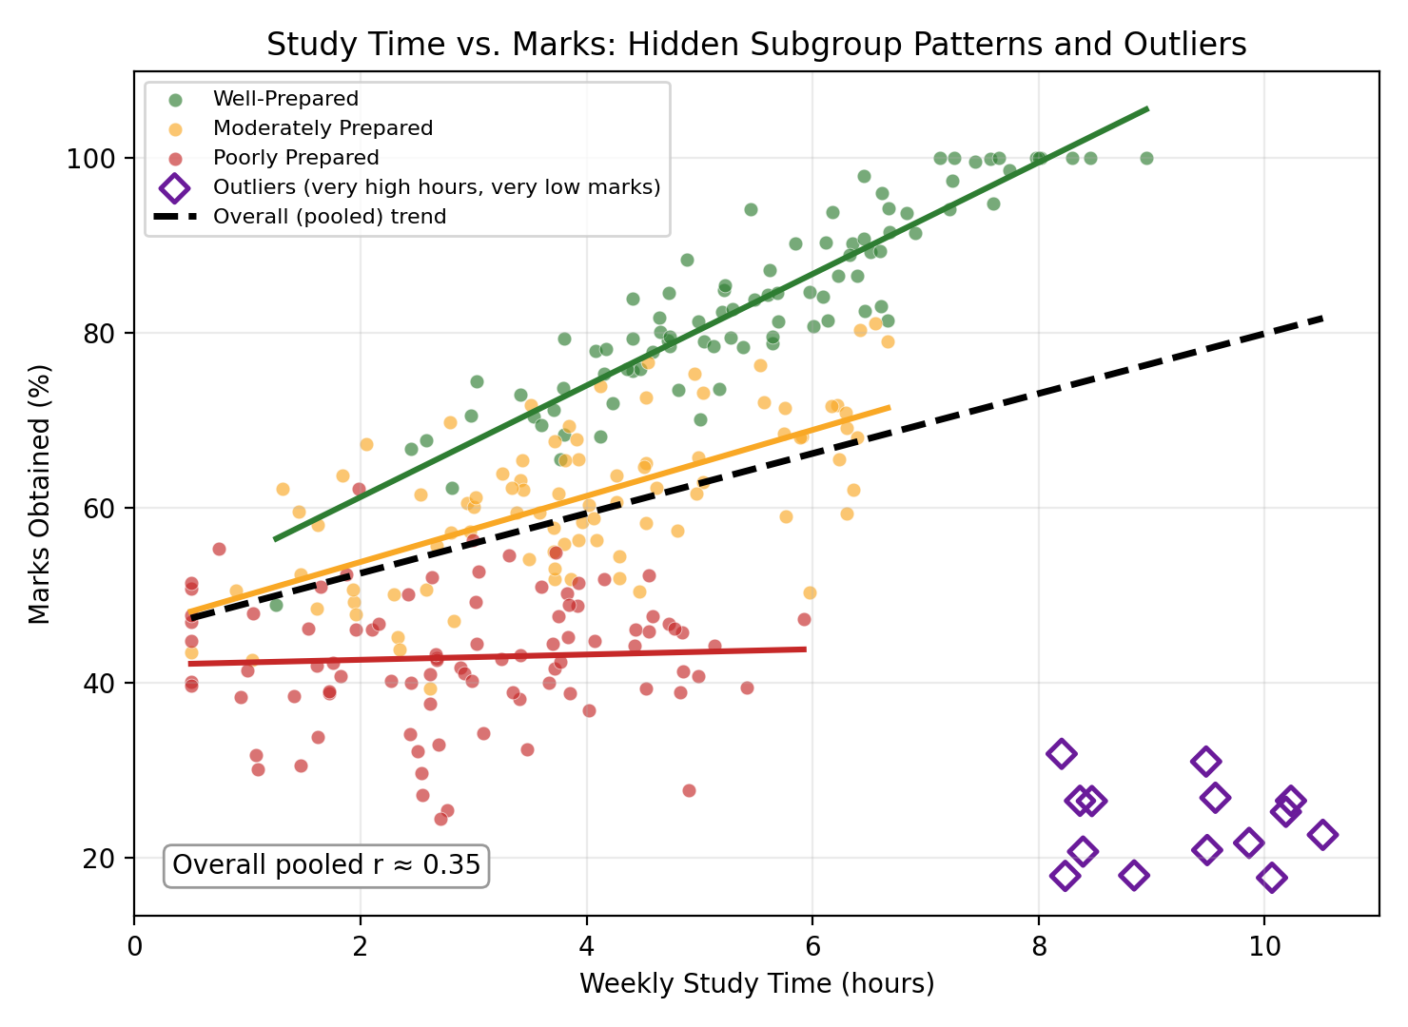
Figure 3.2 — Study time vs. marks by preparation subgroup. Each subgroup (colored) shows its own trend line; the black dashed line is the misleadingly flat 'overall' trend. The purple diamonds mark a small outlier group that studies very long hours but scores very low.

3. The Role of Outliers and Interaction Effects
A small group of students studies extremely long hours yet obtains very low marks (purple diamonds in Figure 3.2). These outliers pull the pooled trend line downward and toward flatness, further weakening the overall correlation even though they represent a small fraction of the sample. Such students may be using study time inefficiently, studying without understanding (rote memorization), facing external stressors, or experiencing burnout and diminishing returns from over-studying without adequate rest — very different mechanisms from the simple 'more hours, better marks' assumption.
The subgroup differences themselves reveal an interaction effect: study time and preparation level do not act independently on marks — the effect of study time depends on the level of preparation. For well-prepared students, each additional hour translates into a large marks gain; for poorly prepared students, additional hours barely help, likely because gaps in fundamentals limit how effectively that time can be converted into performance. A model that ignores this interaction (i.e., a single overall slope) will systematically misrepresent the true relationship for every subgroup.

4. Analyses to Run Before Drawing a Final Conclusion
Before concluding that study time is unrelated to performance, the professor should:
- Subgroup / Stratified Correlation Analysis — Compute the study-time-marks correlation separately within each preparation level, as shown in Figure 3.1, rather than relying on a single pooled statistic.
- Outlier Detection and Investigation — Identify students with unusually high study time but very low marks (e.g., using boxplots or standardized residuals) and investigate underlying causes (study technique, health, external stress) before excluding or separately modeling them.
- Interaction Term in Regression — Fit a regression model of the form Marks ~ Study Time + Preparation Level + (Study Time x Preparation Level) to formally test whether the slope of study time genuinely differs across subgroups.
- Visualization Before Summary Statistics — Always plot the scatter (colored or faceted by subgroup) before quoting a single correlation coefficient, since one number can obscure both non-linearity and heterogeneity across groups.
- Quality-Adjusted Study Time Measure — Where possible, capture not just hours studied but study effectiveness (active recall, practice tests, focused vs. distracted time), since 'hours' may be a noisy proxy for the true driver of performance.
- Robust / Trimmed Correlation — Recompute the correlation after removing or down-weighting extreme outliers to check how much they are distorting the pooled estimate.

5. Conclusion
The professor's conclusion that 'study time has almost no relationship with academic performance' is not supported once the data is disaggregated. Study time is strongly related to performance among well-prepared students and progressively less so as preparation weakens, with a small outlier group further diluting the pooled correlation. A subgroup-aware, interaction-sensitive analysis — not the single overall correlation — should guide any conclusion or policy recommendation.

Question 5: Advertising Expenditure and Sales Revenue (Time-Trend Confound)
A retail company analyzed five years of monthly sales data and found a very strong correlation of 0.93 between advertising expenditure and sales revenue. Management concluded that 'advertising is responsible for the increase in sales, so increasing the advertising budget will proportionally increase revenue.' Further investigation revealed several other changes occurring over the same period. This is examined below.

1. The Reported Relationship Over Time
Figure 5.1 shows advertising expenditure and sales revenue plotted together over 60 months. Both series rise steadily and almost in parallel, producing the strong raw correlation of 0.93 that management is relying on.
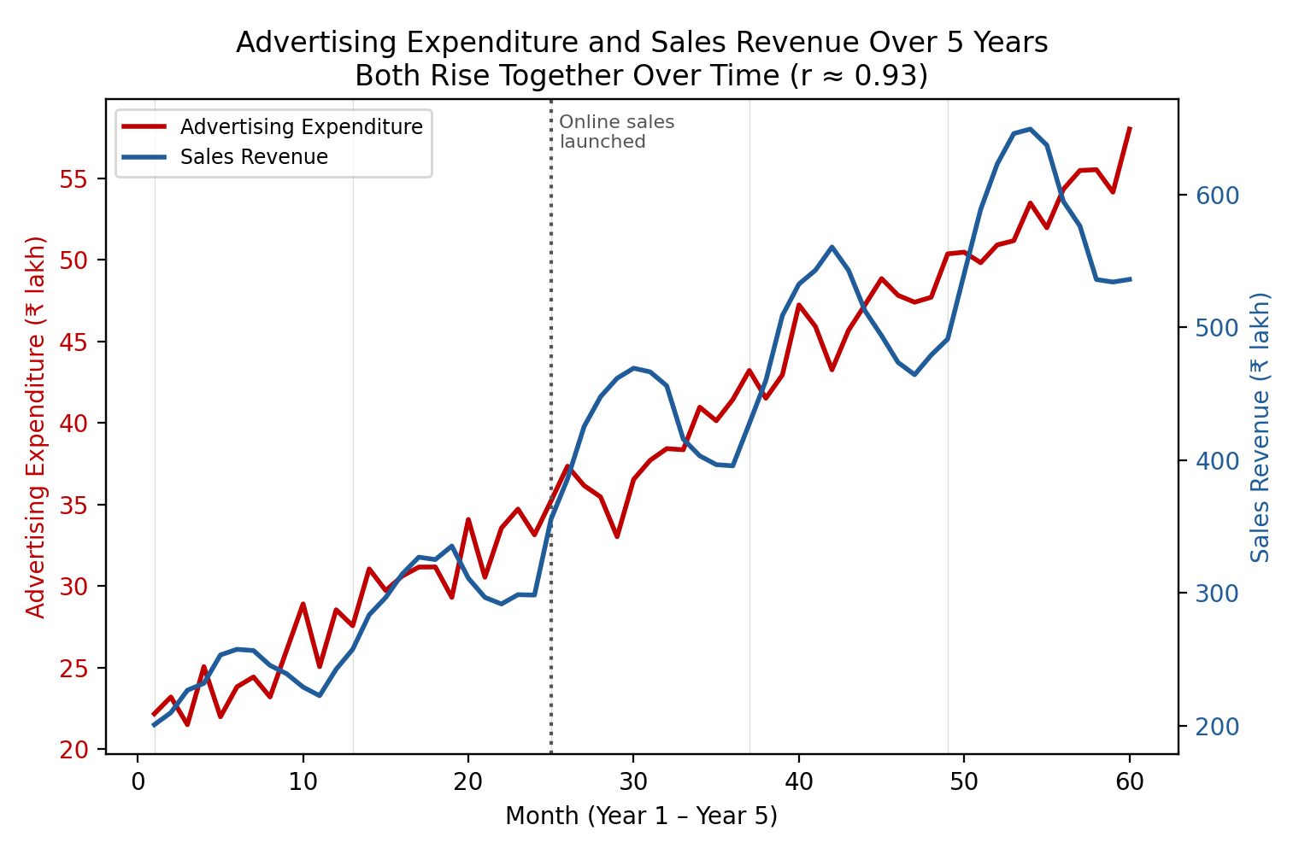
Figure 5.1 — Advertising expenditure and sales revenue over 5 years. Both trend steadily upward, driven partly by shared underlying growth factors (new stores, price increases, expanding customer base, and the online launch in Year 3).

2. Why r = 0.93 Is Not Sufficient Evidence of Causation
A correlation of 0.93 between two variables that are both steadily increasing over time is a classic sign of a shared trend (sometimes called a spurious or trend-driven correlation) rather than a direct causal link. Time itself is acting as a hidden common driver: many unrelated factors — store expansion, price increases, a growing customer base, seasonal cycles, and the launch of online sales in Year 3 — are all pushing sales upward independently of advertising, while advertising expenditure is simply being increased steadily as a matter of routine budgeting ('almost every year regardless of short-term sales performance'), not in direct response to, or in proportion with, actual sales performance.
Figure 5.2 demonstrates this directly. The left panel shows the raw advertising-sales relationship (r is about 0.93). The right panel shows the same two variables after the shared time trend has been mathematically removed from each (i.e., looking only at month-to-month fluctuations around each series' own trend line). Once the common upward trend is removed, the relationship nearly disappears (r is about -0.16), showing that most of the original 'strong correlation' was simply two series moving upward together over time, not month-by-month co-movement caused by advertising.
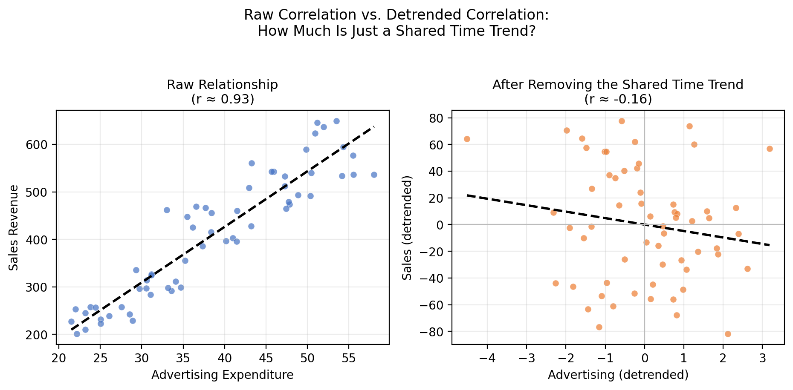
Figure 5.2 — Raw correlation (left) vs. correlation after removing the shared time trend from both series (right). Most of the apparent relationship is explained by the common upward trend, not a direct advertising effect.

3. Patterns That Should Be Investigated Separately
- Underlying Growth Trend — Store count, customer base size, and general market growth over the five years, which would raise sales independent of advertising.
- Pricing Changes — Product price increases mechanically raise revenue even if unit sales volume stays flat or falls, inflating the 'sales' figure without any change in demand driven by advertising.
- New Store Openings — Each new store adds incremental sales; if advertising spend also scales with the number of stores, both variables rise together for a structural, not a causal, reason.
- Online Sales Channel Launch (Year 3) — A step-change in the sales series around month 25 (visible in Figure 5.1) that is a one-time channel effect, not a response to advertising.
- Seasonality — Recurring annual peaks (e.g., festive or year-end seasons) that create predictable up-and-down cycles unrelated to advertising spend.
- Budgeting Practice vs. Performance-Linked Spend — Since advertising expenditure rose almost every year regardless of short-term sales performance, it behaves like a fixed or growing budget line item rather than a lever tied to actual sales response, weakening the case that advertising is driving the observed pattern.

4. Proposed Analytical Workflow
To properly assess whether advertising expenditure has a genuine causal effect on sales, the company should follow a structured workflow:
- Visualization First — Plot both series over time (Figure 5.1) and inspect for shared trends, step-changes (e.g., online launch), and seasonal cycles before computing any single correlation coefficient.
- Time-Based Decomposition — Decompose both series into trend, seasonal, and residual components (e.g., using moving averages or seasonal-decomposition methods) to separate long-term growth and seasonality from short-term fluctuations.
- Detrended / Differenced Correlation — Recompute the correlation on detrended or differenced (month-over-month change) data, as in Figure 5.2, to test whether advertising and sales move together once the shared trend is removed.
- Subgroup / Segmented Analysis — Analyze the relationship separately before and after the online launch, and separately across store-opening periods, to isolate advertising's effect from these structural shifts.
- Multiple Regression with Controls — Model sales as a function of advertising while controlling for number of stores, average price, customer base size, month/season, and an online-channel indicator, to estimate advertising's independent contribution.
- Statistical Testing (Granger Causality / Lagged Effects) — Test whether changes in advertising expenditure precede changes in sales (rather than merely coinciding with them), and examine lagged relationships (e.g., does this month's advertising predict next month's sales).
- Controlled Experiments (A/B or Regional Tests) — Where feasible, vary advertising spend across comparable regions or time windows while holding other factors constant, to directly test the causal impact of advertising on sales.

5. Conclusion
A correlation of 0.93 between advertising expenditure and sales does not prove that advertising is responsible for the increase in sales. Much of the association likely reflects a shared upward trend driven by store expansion, price increases, customer base growth, seasonality, and the online-channel launch. Only after decomposing the trend, controlling for these factors, and testing for a genuine, time-ordered, independent relationship should the company treat advertising spend as a reliable driver of proportional revenue growth.

